**Project 7 Coin Detection with OpenCV**

Name: Varun Asuri Period: 3 Date: 5/27/2021

Did you name your file l071.cpp (Lower case L, then 071)? yes

Did you use OpenCV to detect coins? yes

What functions/methods from OpenCV did you use?

Mat, imread(), medianBlur(), HoughCircles(), circle(), Scalar(), imwrite()

__________________________________________________________________________________

What functions/methods from OpenCV did you experiment with but ended no using?

GaussianBlur(), Canny()

Below do the following for each of the 3 images I provided paste 2 clear pictures of the initial picture, the picture with the original image and the circles you detected drawn in red (bolded and you may use more colors if you wish) and also the content of your results.txt file

Done in Jupyterhub

I optimized my thresholds for the hard image so it may compromise the other seemingly easier ones at the benefit of an astonishingly better result in the hard one that you can see on the bottom.

1. For the easy image: (paste in next line)

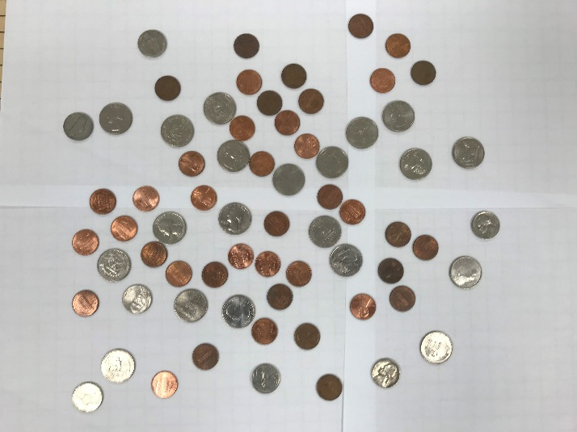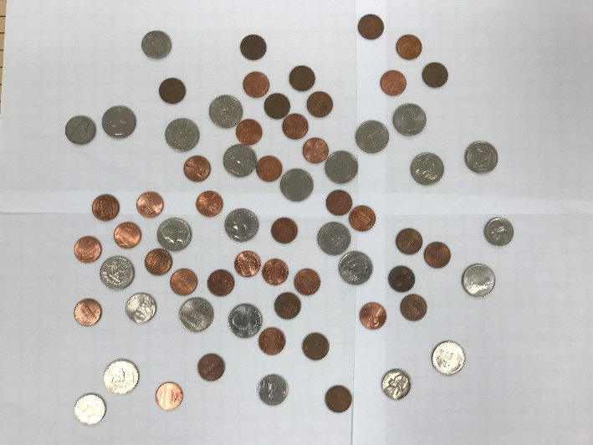

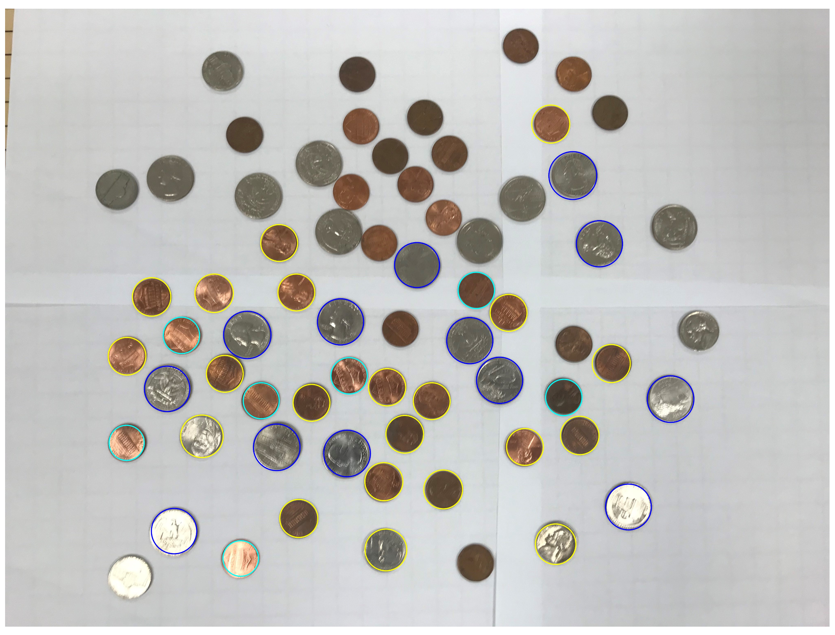 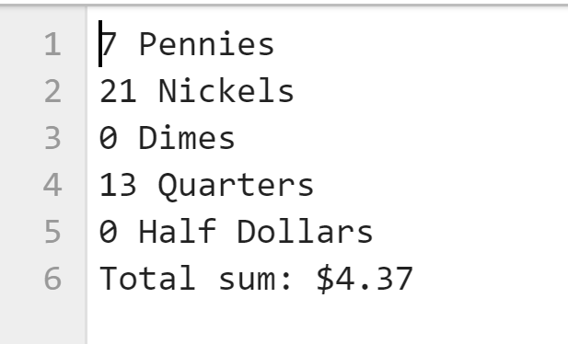

1. For the medium image: (paste in next line)

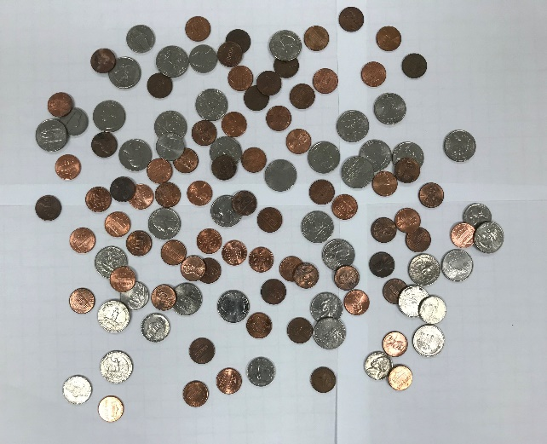

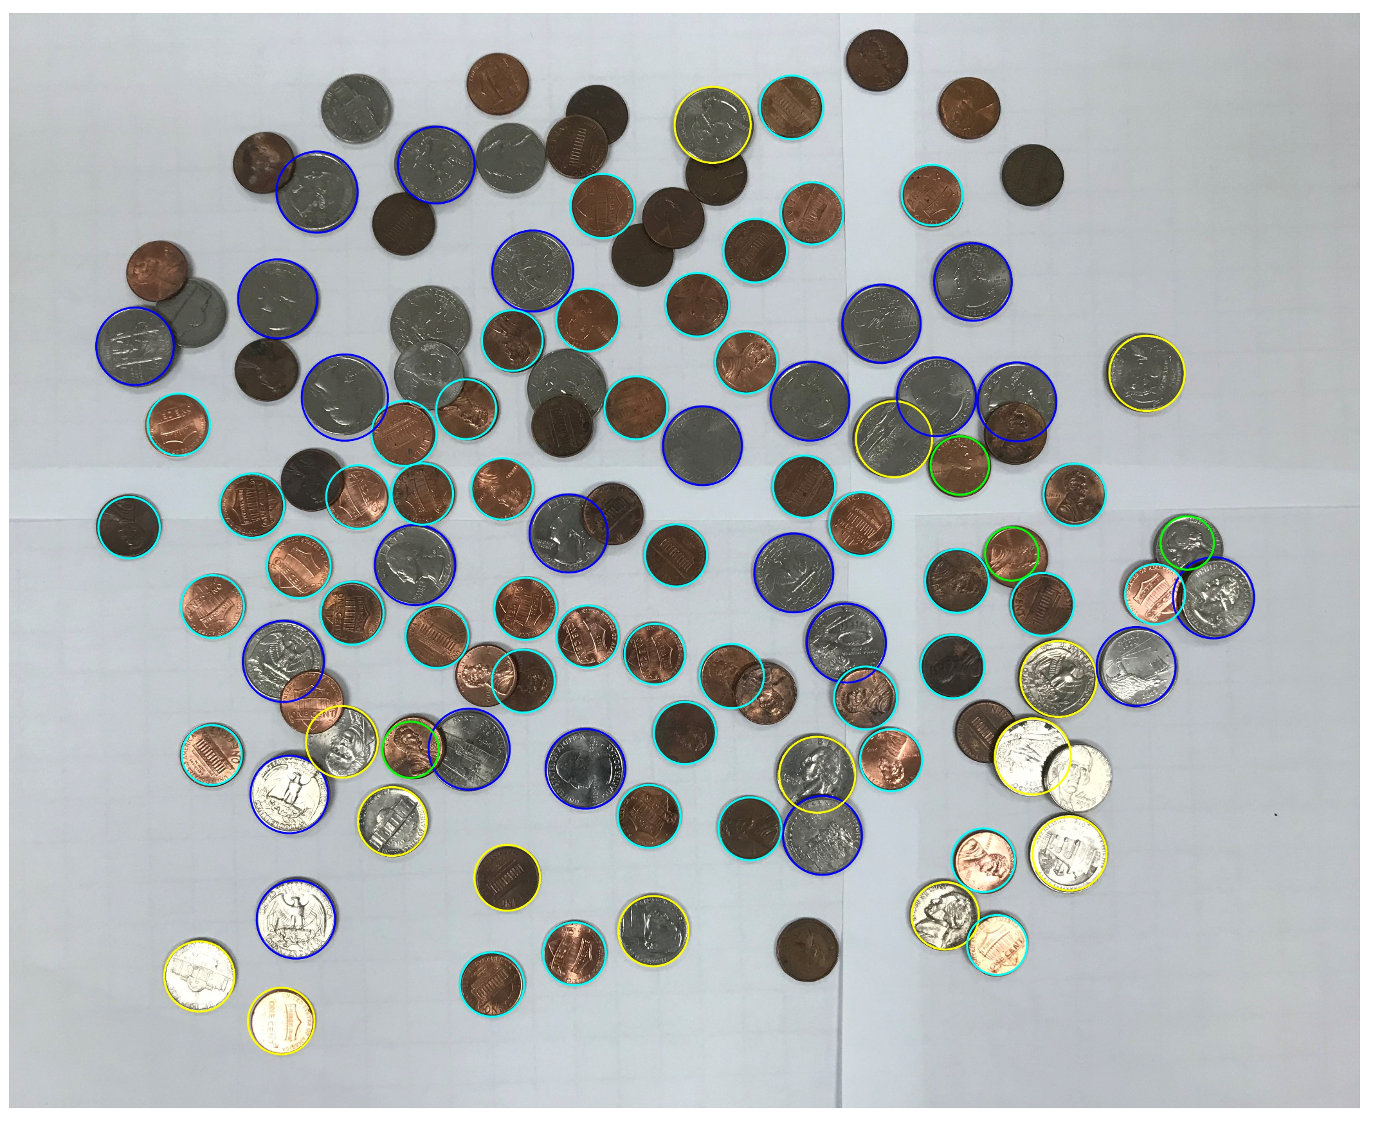 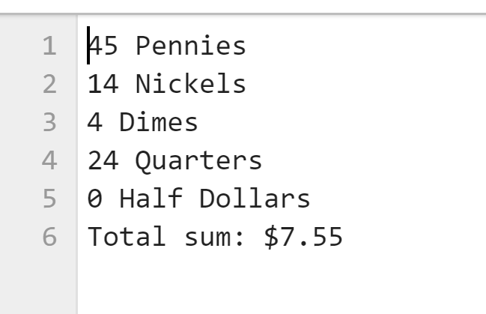

1. For the hard image: (paste in next line)

